***Co4***

1. ***Pgm 1***

class Rectangle:

def __init__(self, length, width):

self.length = length

self.width = width

def compute_area(self):

return self.length * self.width

def compute_perimeter(self):

return 2 * (self.length+self.width)

l= float(input('Please Enter the Length of the Rectangle: '))

w= float(input('Please Enter the Width of the Rectangle: '))

object1 = Rectangle(l,w)

area = object1.compute_area()

perimeter = object1.compute_perimeter()

***out put***

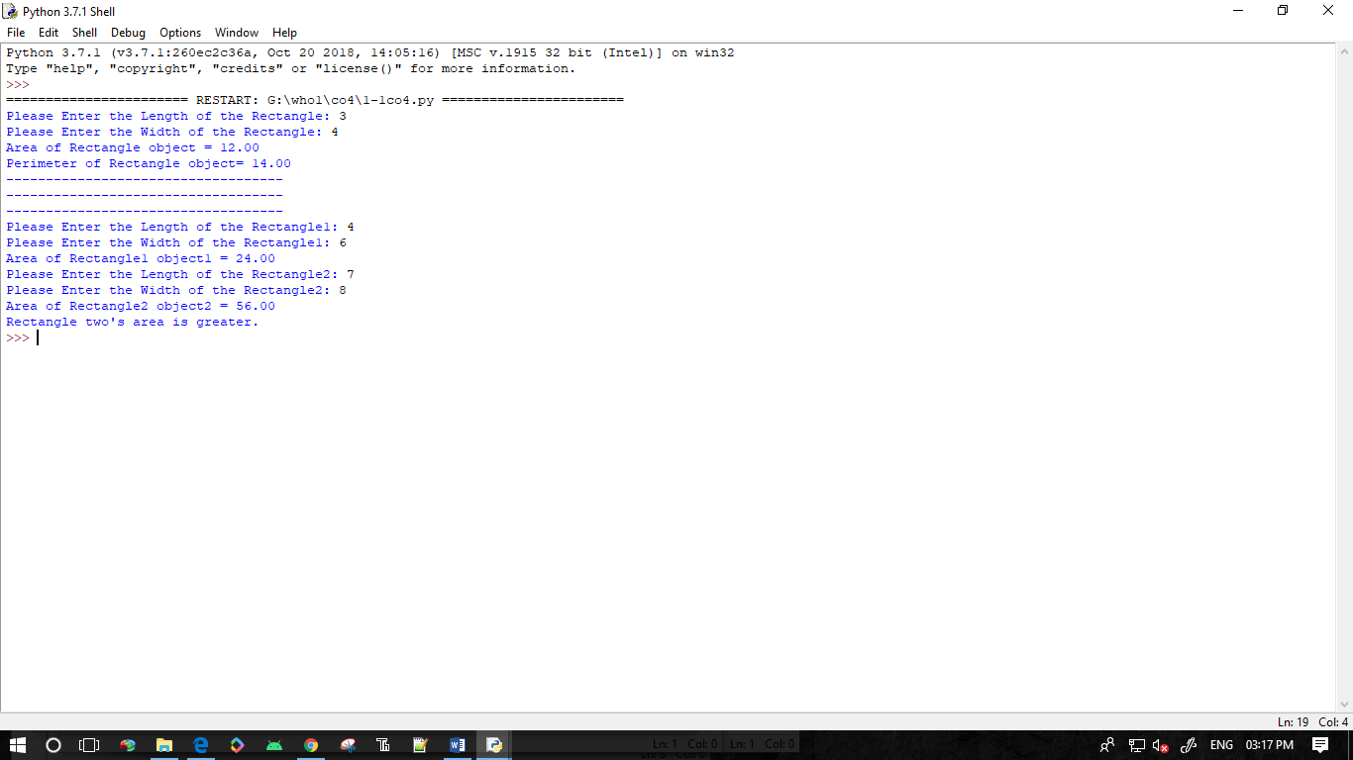

1. ***Pgm 2***

class bank:

__acc_name=""

__acc_no = ""

__acc_type = ""

__acc_balance = 0

def __init__(self,a_name,a_no,a_type,a_balance):

self.__acc_name = a_name

self.__acc_no = a_no

self.__acc_type = a_type

self.__acc_balance = a_balance

def deposite(self,a_deposit):

print("Initial balance is : ",self.__acc_balance)

print("Deposite is : ",a_deposit)

self.__acc_balance += a_deposit

print("Current balance is : ",self.__acc_balance)

def withdraw(self):

print("Current balance is : ",self.__acc_balance)

self.amount = int(input("How much amount need to withdraw : "))

if self.amount > self.__acc_balance:

print("You don't have enough balance to withdraw !!")

print("Current balance is : ",self.__acc_balance)

else:

print(self.amount," is withrawed .")

self.__acc_balance -= self.amount

print("Current balance is : ",self.__acc_balance)

def acc_info(self):

print("\n\n\n\n")

print("Account holder name : ",self.__acc_name)

print("Account number : ",self.__acc_no)

print("Account type : ",self.__acc_type)

print("Account Balance is : ",self.__acc_balance)

print("\n")

def main():

name = input("Enter Account holder name : ")

no = input("Enter Account number : ")

atype = input("Enter Account type : ")

bal = int(input("Enter Account initial balance : "))

holder = bank(name,no,atype,bal)

while(True):

print("\n\n")

opt = int(input("1)Deposite \n2)Withdraw \n3)Account info \n0)Exit\nChoose your option :: "))

print("n\n")

if opt == 1:

amount = int(input("Deposite amount : "))

holder.deposite(amount)

elif opt == 2:

holder.withdraw()

elif opt == 3:

holder.acc_info()

elif opt == 0:

break

else:

print("Invalid Option !")

if __name__ == "__main__":

while(True):

main()

***out put***

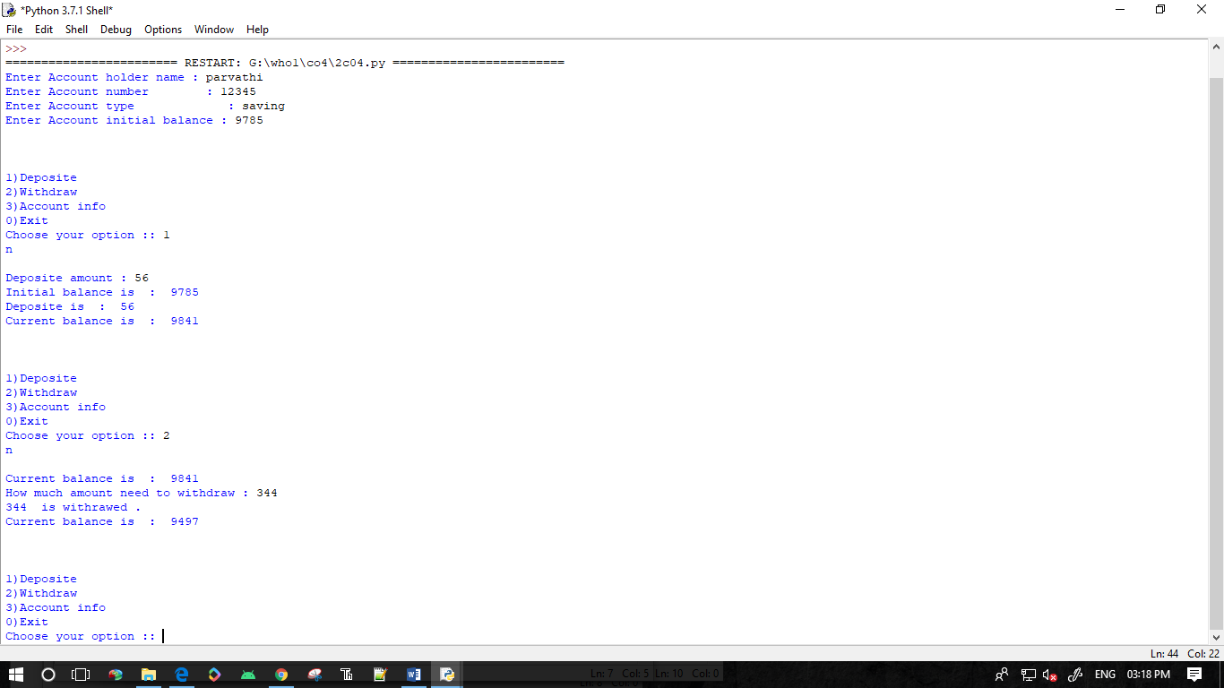

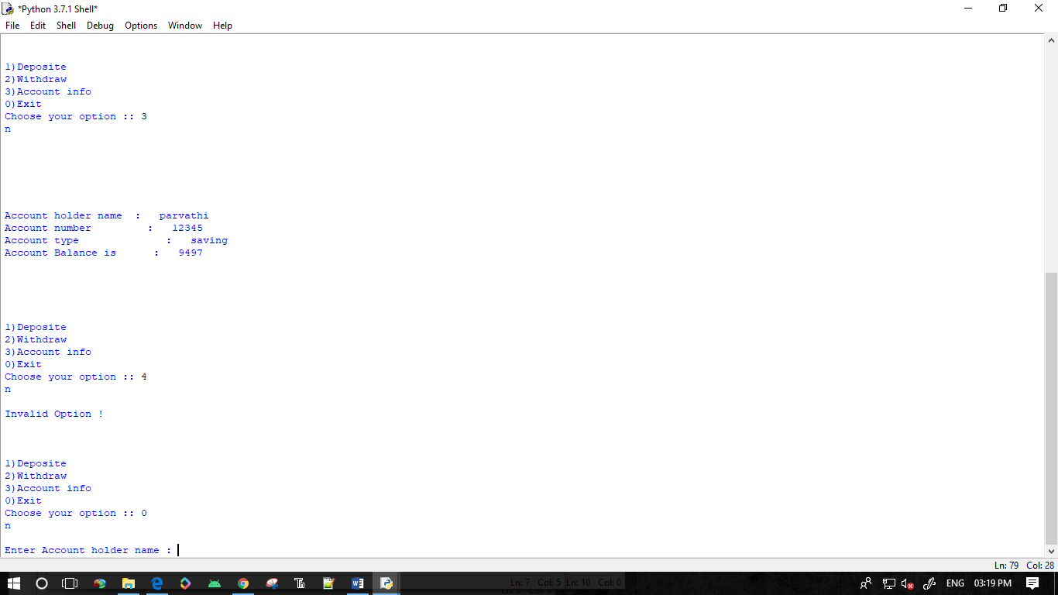

1. ***Pgm 3***

class rectangle:

def __init__(self,length,width):

self.length=length

self.width=width

def __lt__(self,a1):

area1=self.length*self.width

area2=a1.length*a1.width

if(area1>area2):

return(True)

else:

return(False)

print("Enter the Details of Rectangle:1")

l1=int(input("Length:"))

w1=int(input("width:"))

r1=rectangle(l1,w1)

print("Enter the Details of Rectangle:2")

l2=int(input("Length:"))

w2=int(input("width:"))

r2=rectangle(l2,w2)

if(r1>r2):

print("Rectangle 2 is larger!!")

else:

print("Rectangle 1 is larger!!")

***out put***

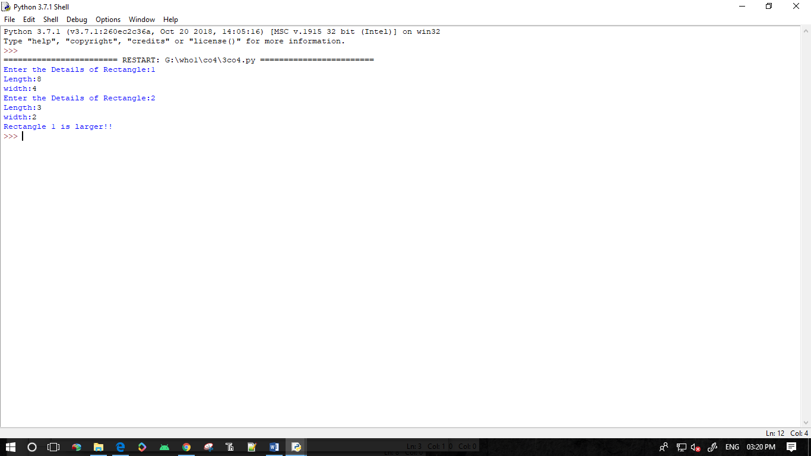

1. ***Pgm 4***

class Time:

def __init__(self,hour,minute,second):

self.__hour=hour

self.__minute=minute

self.__second=second

def __add__(self,a2):

second=self.__second+a2.__second

minute=self.__minute+a2.__minute

hour=self.__hour+a2.__hour

if(second>60):

second=second-60

minute=minute+1

if(minute>60):

minute=minute-60

hour=hour+1

return hour,minute,second

print("Enter time1:")

h1=int(input("hour:"))

m1=int(input("minute:"))

s1=int(input("second"))

t1=Time(h1,m1,s1)

print("Enter time2:")

h2=int(input("hour:"))

m2=int(input("minute:"))

s2=int(input("second"))

t2=Time(h2,m2,s2)

hr,min,sec=t1+t2

print(hr,end=":")

print(min,end=":")

print(sec,end=" ")

***out put***

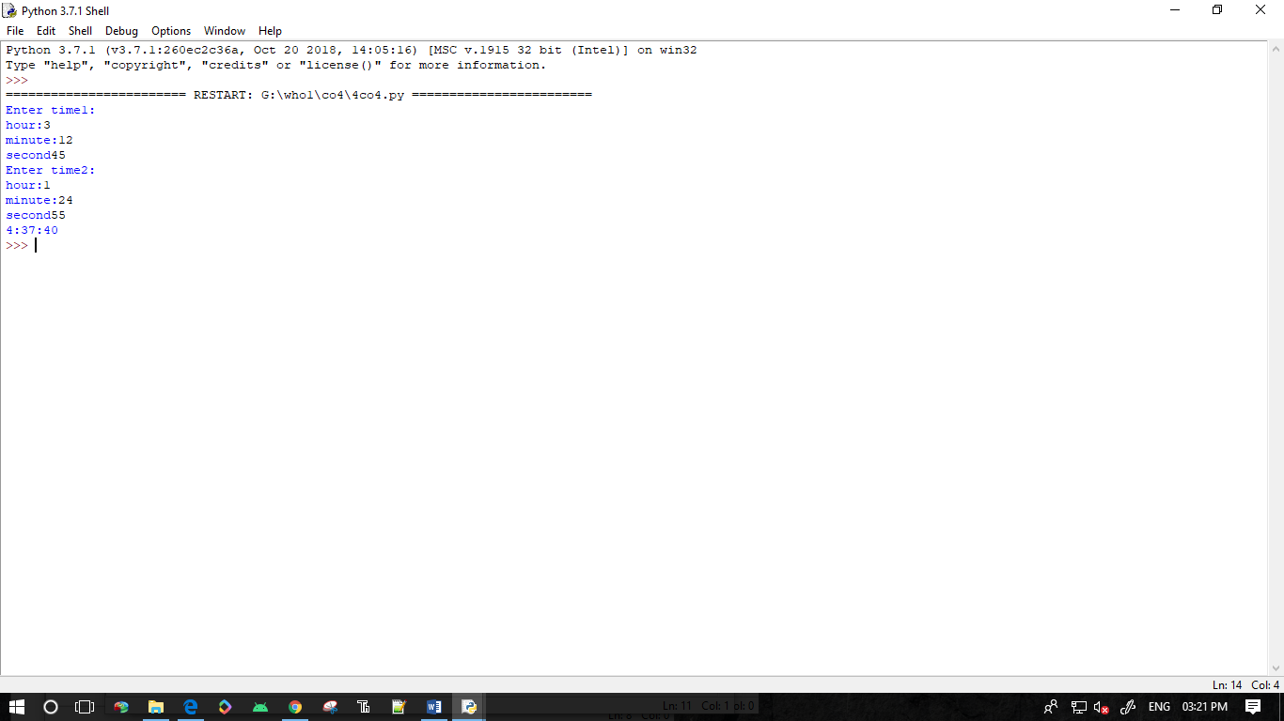

1. ***Pgm 5***

class publisher:

def getbook(self):

self.title=input("title :")

self.author=input("author :")

class python(publisher):

def getdetails(self):

self.price=int(input("price :"))

self.nopages=int(input("nopages :"))

def display(self):

print("title of the book is :",self.title)

print("author of the book is :",self.author)

print("price is: ",self.price)

print("number of pages :",self.nopages)

a=python()

a.getbook()

a.getdetails()

a.display()

***out put***

